International Conference on Sustainability in Energy and Buildings
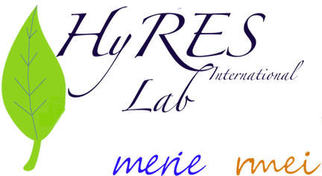

Invited Sessions
HyRES for Med Green Energy

Title of Session:
Hybrid Renewable Energy Systems with multiple Sources for Med Green Energy

Name of Chair: Nacer K. M’Sirdi and M. Boussak

Description:
The Mediterranean countries have their specificities linked to geography meteorology and cultures. This has an important impact on the renewable energy resources and the energy uses and demand. Using existing solutions need very often an adaptation and adjustments; This is the main interest of the Mediterranean green energy network and the Mediterranean researchers.
This session has the objective to point out some specific problems related to Energy demand and production and then try to define specific solutions.
The topics of the papers in this session are mainly:
- Control and monitoring of multiple energy systems
- Prediction of energy production and demand
- System adaptation for grid connections
- Smart grids and energy distribution and sharing
- Smart and multi layer grids
- Optimal control and connections adaptation.

Website URL (if any): http://nkms.free.fr/MGEF/MGEN.htm

Email & Contact Details: nacer.msirdi@rmei.eu
Nacer K M’Sirdi, professor AMU (Aix Marseille University.

